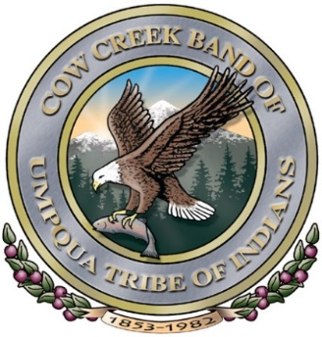
For release For more information, contact:
June 24, 2025 Susan Ferris 541.672.9405
Carma Mornarich 541.672.9405

Cow Creek Umpqua Indian Foundation (CCUIF) Awards $759,230 to
Eighty-Four Non-Profits at Seven Feathers Convention Center
in Canyonville on Tuesday, June 24, 2025, at 1 p.m.

Canyonville, Oregon……. Seven hundred fifty-nine thousand,
two hundred thirty dollars will be awarded by the CCUIF to 84 non-profits at Seven Feathers
Convention Center on Tuesday, June 24, 2025, at 1 p.m.

Non-profits receiving awards are located in Coos, Deschutes, Douglas, Jackson, Josephine,
Klamath, and Lane Counties.

The CCUIF was founded in 1997 and began its philanthropic efforts in 1998. To date, the Foundation has awarded $26,440,058 to non-profits in the seven Southwestern Oregon counties from which it accepts grant requests. Grants are awarded semi-annually, in January and June. In January of 2025, the CCUIF awarded 86 non-profits a total of $751,580.

According to Carma Mornarich, Executive Director of the CCUIF, ” The work of the Cow Creek Umpqua Indian Foundation strengthens communities in southwestern Oregon. The dedication of community volunteers and non-profit organizations benefit our region immensely, which is critical to solving societal problems. Cow Creek believes strong communities build strong people. Since their beginnings, Cow Creek have been strong and active in community life.”

The mission of the Cow Creek Umpqua Indian Foundation is to offer assistance in education, strengthen youth and family, provide for positive youth development, and to add to the quality of life for people in Southwestern Oregon. The Foundation has put increasing emphasis upon basic needs in recent years so more hungry people are fed.

The Cow Creek Umpqua Tribe of Indians has a long tradition of giving back to communities where the Tribe lives and works. In 1997, the Tribe formalized this established history by creating the CCUIF. Foundation awards are made separately from and in addition to the regular philanthropic decisions made by the Cow Creek Tribal Board.

# # #

