Overview
This document is designed to provide grant applicants with instructions for use of the Foundant Grant Lifecycle Manager application. Remember while this document attempts to provide step-by-step instructions, we realize that not all user scenarios may be adequately covered. If you remain on a page with inactivity for longer than 40 minutes, you will be logged off for security reasons. Please save every 15-25 minutes.

Registration Page
If you already have an account with this Foundant Grant Lifecycle Manager;
- Enter your login, which is your e-mail address, in the login field
- Enter the Password that you chose when you set up your account.
- Press the “Log On” button to enter the Grant Lifecycle Manager.
If you have forgotten your password;
- You can click on the Forgot your Password button, enter your User ID, and the system will email your password to your e-mail account.
If you do not have an existing account;
- Click on Create New Account to register.
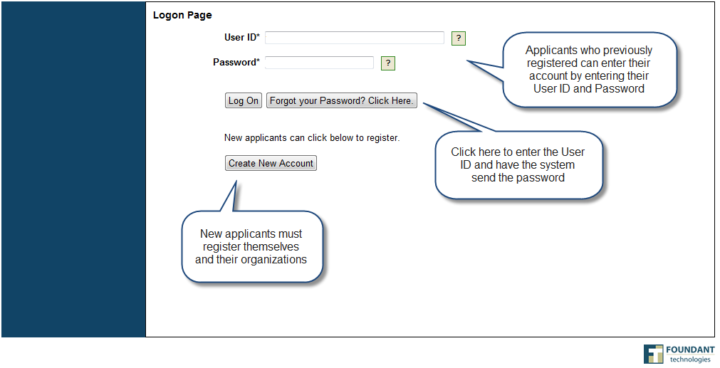

To register an account
- Click on Create New Account
- Enter your personal contact information
- Enter your organization’s contact information
- Click on the Proceed to Next Step button
(See diagram on next page)

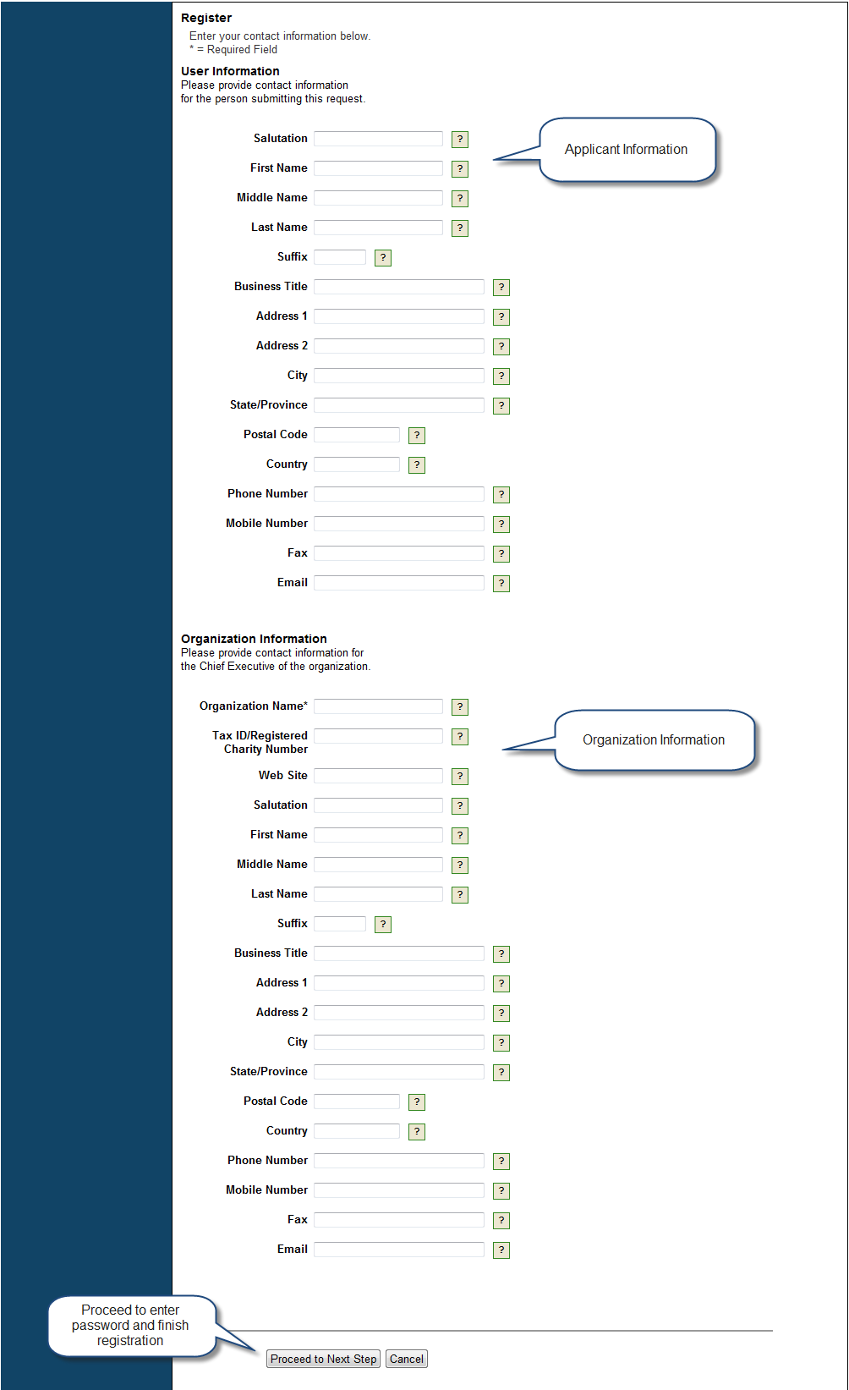

Entering a Password
- After you have registered your account, you will be taken to a Set Password Page where you will enter your password.
  - After entering the passwords click save
- Next you will confirm the password in Red. If you wish to change your password, log on to your account and click on Edit Contact. This will allow you to change your information.

Login and Password Confirmation Page
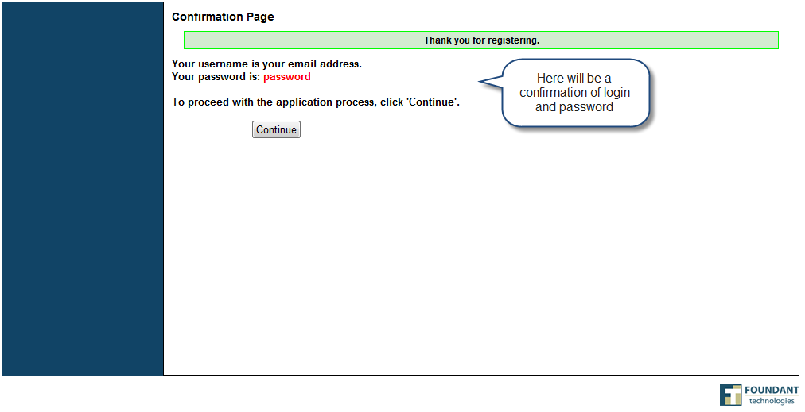
Applicant Status Page
After you have registered your account you will be directed to the Application Status Page.
- Start New Application – This allows you to review the available grants and apply.
- Application Status – This is your homepage where you can check on the status of your grants. This page will display the form you just filled out, what its status is, and what the next form will be.
- Fax to File – Instead of scanning a document you can fax it to your computer. Using Fax to File helps shrink documents to a smaller file size.
Application Status Page
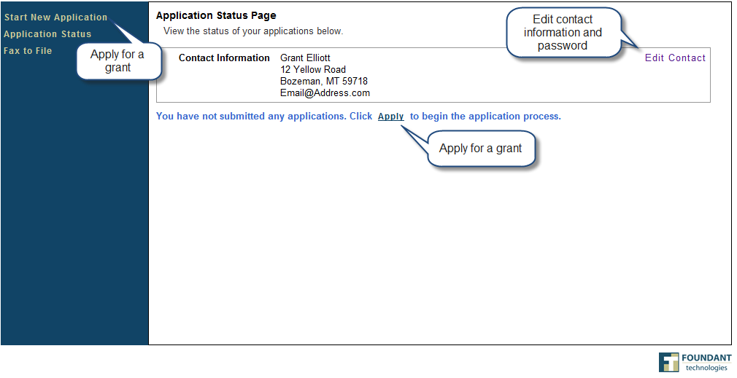

Choosing a Grant Program
After clicking on the Start New Application link you will have the ability to choose a grant program to apply for. Each grant program will have a brief description of the grant or who qualifies for the grant. Read these descriptions thoroughly before applying.
- Read through the grant program description to decide if you qualify to apply for the grant.
  - If the foundation has sent you an access code enter it in the Access Code box on the left and click Enter. This will allow your private grant program to appear.
- After the grant program appears, click it to start filling out the first form.
  - Grant Programs have the ability for multiple forms. Some grant programs can have the applicant submit 3 forms to the foundation before a decision is made. Each form will be filled out and submitted to the foundation. After it is deemed complete, the foundation will approve you to move on to the next form.

Choosing a Grant Program

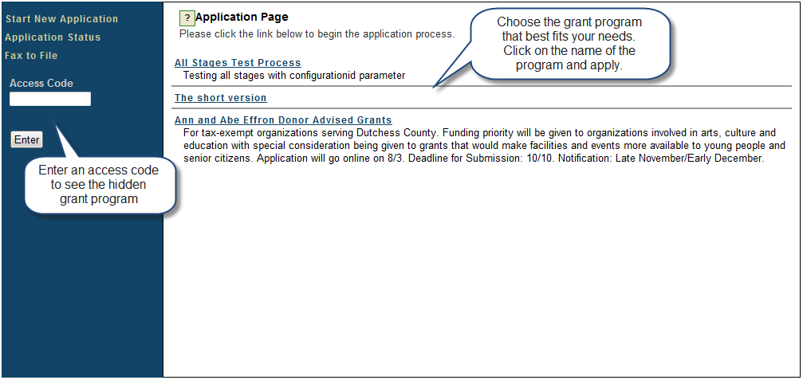

Applicant Instruction Page
- For security risks, our software automatically logs you off if there is no activity on the system for over a 40 minute time period. Please click Save as Draft early and often.
  - Click the box stating that you understand the applicant instructions and then click Continue.

Agree to the Applicant Instructions
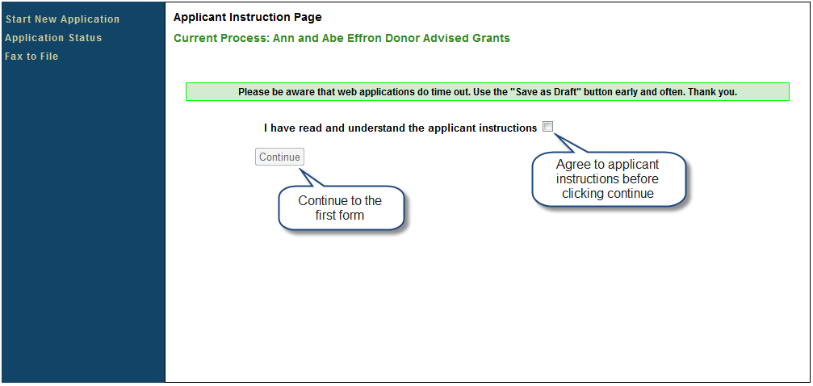

Filling out the First Form
After agreeing to the applicant instructions you will be sent to the first form in the grant program. Enter all the applicable information then Save as Draft or Submit the form to the foundation.
- Start filling out the questions on the form, paying close attention to the instructions and limitations on each question.
  - Certain types of questions have limitations set by the foundations. Text questions will have a character limit which only allows you to type or paste a certain amount of text in each question. Another limit will be on the file upload questions. This limit will be in Mega Bytes (MB). The size of file you are uploading must be under the amount of MB’s allowed on the question.
- Applicants can save as draft and come back to the form after any given time to complete it. The foundation will not check for completeness until the form is submitted.
  - After the application is submitted there will be a confirmation page stating that the form has been submitted. You can always refer to your Application Status Page to see what stage the application is in, if in doubt.

(See diagram on next page)

Completing a Form
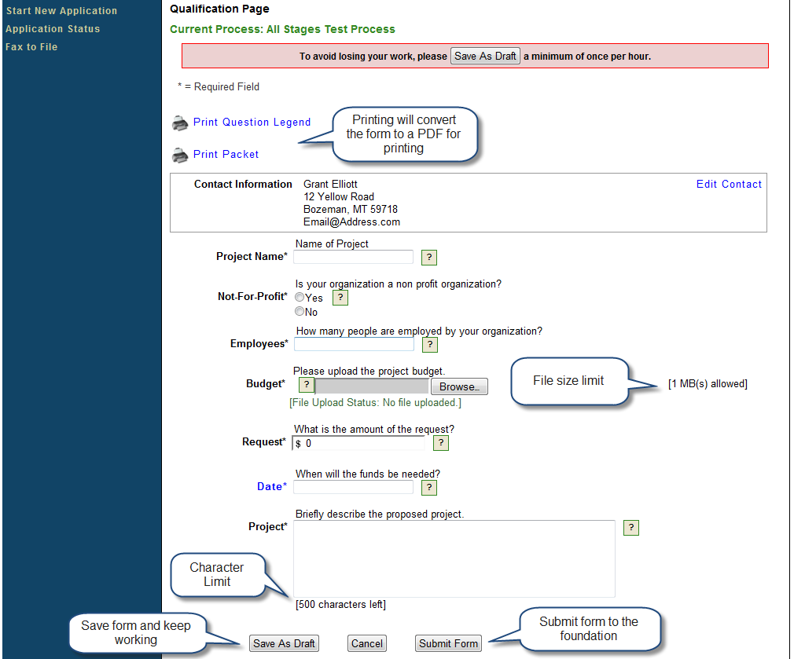

Accessing Forms After Save and Submit
The Application Status Page is where you can check on the status of your applications and access for historical record keeping. The Application Status Page is your homepage. You will be automatically directed there when you login.
- If you’ve submitted the grant then you can only view the grant and print it.
- If you saved the form then you can Edit the saved form from the Application Status Page.

Application Status Page
